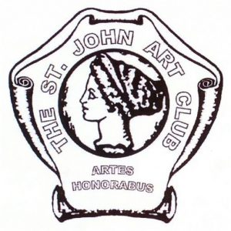
Saint John Art Club Inc.
Visual Art Scholarship
Application 2020
Revised for electronic use.

Value $1,000.00
Application Deadline: May 23, 2020
Because our gallery is temporarily closed and we are all staying home we have decided to award our scholarship this year based on digital images and electronically transmitted applications.
To complete this form, open it in a word processor such as Word or Pages and fill in down to the date. Then attach it to an email along with JPEG images of four art works and your acceptance letter from art school. Send it to your art teacher or instructor so they can complete the last part. Also please send a copy to meekd@nbnet.nb.ca
I apologize for the rather make shift form: I’m new to word. If you have difficulty with it, just type the information into an email instead!

Name:

Address:

City: Province: Postal Code:

Home Phone: Cell Phone:

Email:

Current School Teacher or other art instructor

Secondary Educational Institution and program you will be attending (attach Photograph of acceptance letter):

Art Portfolio submission: Select four works that show originality of composition and the diversity of your ability. Include landscapes, portraits and still-life. Oil, acrylic, watercolour, pastel, charcoal, graphite, pen and ink are acceptable. Please attach a JPEG image of each work to the email with this application. For each image give the title, medium, and size.

If you are chosen to be a recipient of the scholarship, we would like to post images of your work on the art club facebook page. Do you agree to this?

Artist Profile: Complete a personal profile by describing yourself in 250-300 words and attach it to the application. Explain your interest in and pursuit of the visual arts; how you began, and what you hope to do upon completion of your post-secondary education. Describe the mediums and styles you have used and what is the most satisfying component when working with your art? What would you tell the SJAC Educational Committee about yourself that would encourage them to consider you for this scholarship?
Type here:

Date:

Now please email this form to your teacher with images attached so they can complete their recommendation. Remember to send a copy to me just in case anything gets lost. I look forward to seeing your work and wish you good luck.

Saint John Art Club Inc.
Visual Art Scholarship
Teacher recommendation 2020

Students Name__________________________________________________

Visual Arts teacher/instructor Recommendation:
In this email, please describe the scholarship applicant’s work, interests and pursuance of the visual arts. What would you say to the committee to encourage them to select this student? Please comment on first hand evidence of the student’s aptitude, dedication and passion; or any other relevant information you may wish to add. Also please attest that the attached images are the original work of the student.
All information is confidential and will be shared only with the committee members. It will be deleted upon completion of the SJAC Education Committee's selection.
Type here:
Please email your recommendation directly to me at meekd@nbnet.nb.ca

Thank you and kindest regards,

David Meek
Chairman Scholarship Committee 506-647-8504 meekd@nbnet.nb.ca

